Managing SSRS reports in RayFlow 1.10

- Configuring a report object to target a RDL file.

As a clean install of RayFlow 1.10 creates four report objects that target the four provided RDL files, it is only upgrade scenario’s that need to perform this step.

Got to Reports > Reports:
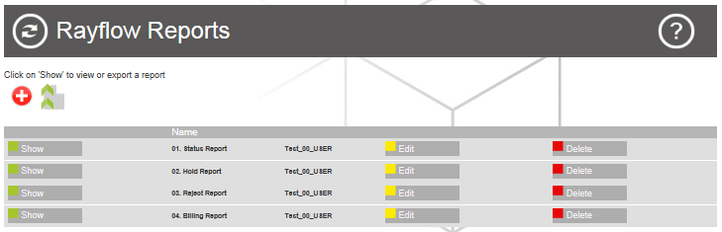

Press the [Add] button:

Enter a name for the report object, a description if you wish, select the relevant RDL file from the File box, and then assign the relevant group to the report object:
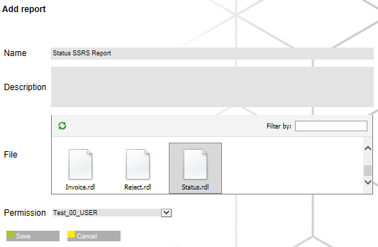

After pressing the [Save] button, press the [Back] button to return to the RayFlow Reports page:
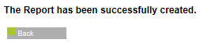

Pressing the [Show] button, allows you to either show the report or go back to the RayFlow Reports page:
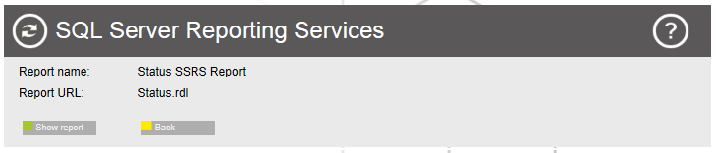

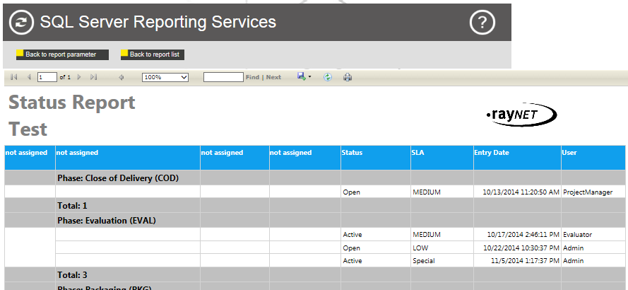

- Configuring the SSRS report to utilise your RayFlow projects data fields.

The provided RDL files are configured to look for certain data field names by default, and if they do not exist within the RayFlow project, they will have “not assigned” as their current column names.

In order to rectify this situation, you need to map the RDL files default column names with data field names from the targeted project.

Got to Configuration > Menu and then press the [Insert Menu] button:

Uncheck the Menu Visible check box, assign the new menu item to the Administrators group, enter “0” as its Order value, enter “Report Fields” as its Menu text value, enter “StandReportFieldMap.aspx” as its Link value, and then press the [Insert Menu] button again.
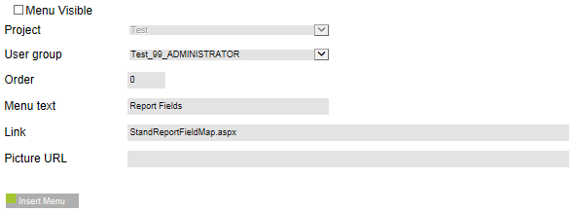

Got to Configuration > Report Fieldmapp:
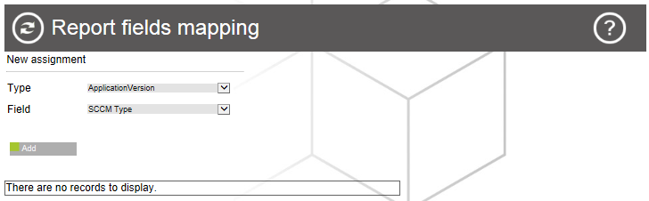

The Type dropdown menu lists the RDL files default column names. The Filed dropdown lists the RayFlow projects data field names. The default column name order is as follows:-

Column 1 = PackageID
Column 2 = ApplicationName
Column 3 = ApplicationVersion
Column 4 = ApplicationVendor

Create your required column name to data field name mappings via the two dropdown menus and the [Add] button:
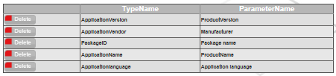

Running the report from now on will display data in all columns:
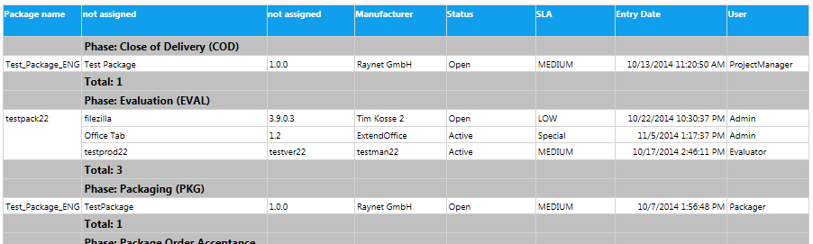

Known Issues:

- Although the RDL files have an Applicationlanguage column name in the Data Fieldmapp menu item, this column is not visible within the report.
- Although columns 2 & 3 display data once mapped, the selected data filed names are not shown as column names.

