Raynet

SLA Calculation in Project mode

RayFlow 2.0

Objective
The objective of this configuration is to define a SLA calculation criterion, which would allow calculating the SLA time period for a task based on the overall time period assigned for the entire workflow phase. The calculation will be done despite of how long a task is active within a particular phase.

Example Scenario
Let’s say, within a RayFlow project, we have a list of tasks from a customer and total number of days assigned to complete those tasks is 10 project days.

Steps

SLA Configuration
- Log in to your RayFlow project as a Project Administrator
- Navigate to Management -> SLA Editor from the left sidebar: SLA Editor is loaded into the current view
- Create a new SLA called X
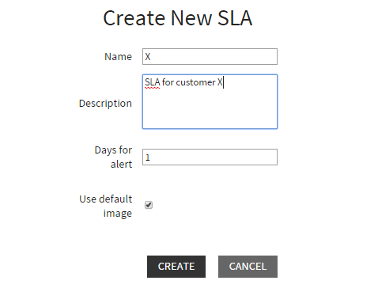
- Select the newly created SLA
- Under the Configuration section, deactivate the top phase (‘Create Phase’) from SLA counting
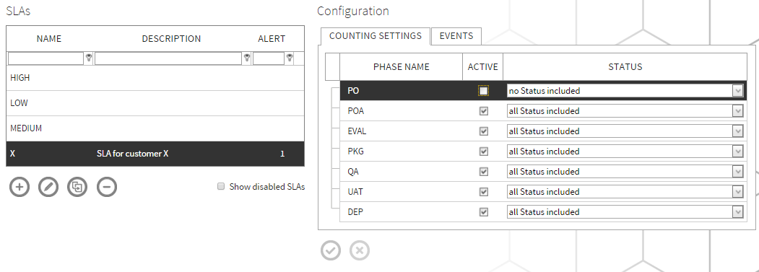
- Select the events tab.
- For all the phases, select Project as calculation mode and put 10 days for the first phase (phase from where the SLA counter should start) and for rest of the phases, put in 0 days.
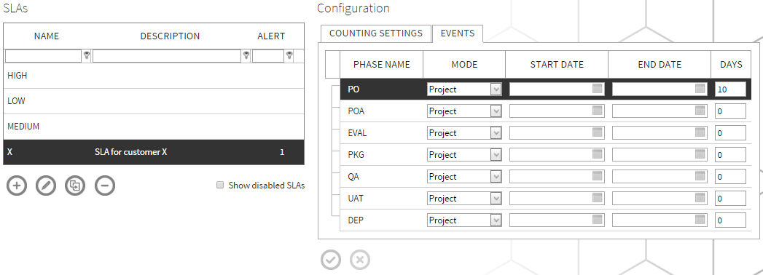
- Save the changes by clicking on the left icon at the bottom of the configuration view.
- Now to test this configuration, create a new task with the newly created SLA as ‘SLA’.
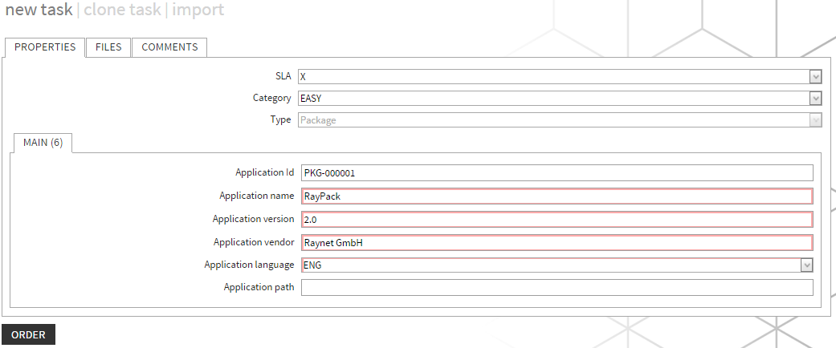
- Manually run the SLA Calculator from the following path <%INSTALLDIR%>\SLACalculator\RayflowSLACalculator.exe
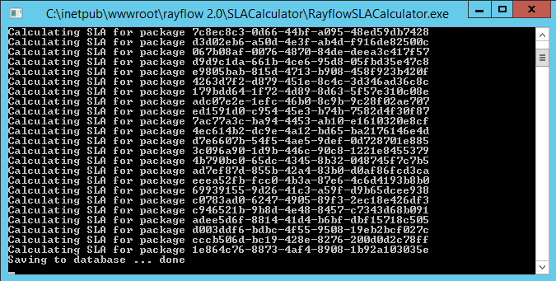
- Now go back to the first phase in which the task is located. The initial time calculation for the task is shown under the REMAINING TIME column header.
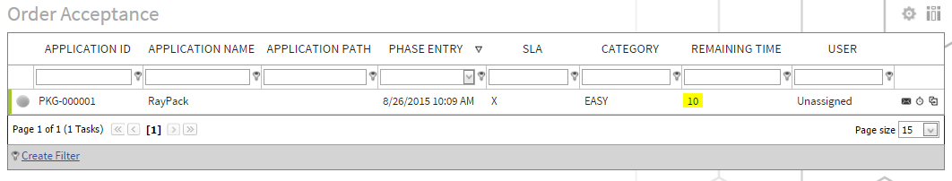
- Now change the status of task to ‘Finished’.
- Manipulate test system clock by adding two days to the current date.
- Run the SLA calculator as shown in step 10 again.
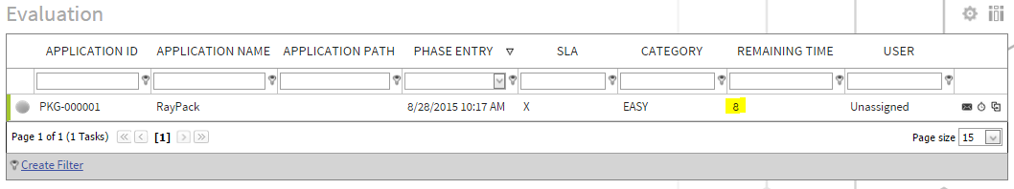
As shown in the image above the REMAINING TIME custom field shows that the task has 8 days remaining.

