Raynet

Configuration Options for Progress Bar

RayFlow 2.0

Objective

This visibility of the progress bar, which is by default shown at the bottom of RayFlow 2.0 screen, can be configured according to a user desire and requirement.

Steps

Open file toastr-options, using a text editor. The script contains following parameters and respective default values for them:

$(document).ready(function() {
toastr.options = {
"progressBar": true,
"positionClass": "toast-bottom-full-width",
"newestOnTop": true,
"timeOut": "5000"
}
});

Parameter (parameter type) | Values
progressBar (boolean) | True: Progress bar is shown, False: Progress bar is not shown
positionClass (string) | Position of the progress bar. Following are the list of acceptable values:  - Top Right  - Bottom Right  - Bottom Left  - Top Left  - Top Full Width  - Bottom Full Width  - Top Center  - Bottom Center
newestOnTop (boolean) | True: Newest update is shown on the top, False: Newest update is shown at the bottom
timeOut(Integer)(Seconds) | Time period in seconds, for which the progress bar is shown to a user

Example

$(document).ready(function() {
toastr.options = {
"progressBar": true,
"positionClass": "toast-bottom-left",
"newestOnTop": true,
"timeOut": "1000"
}
});

Initial state:

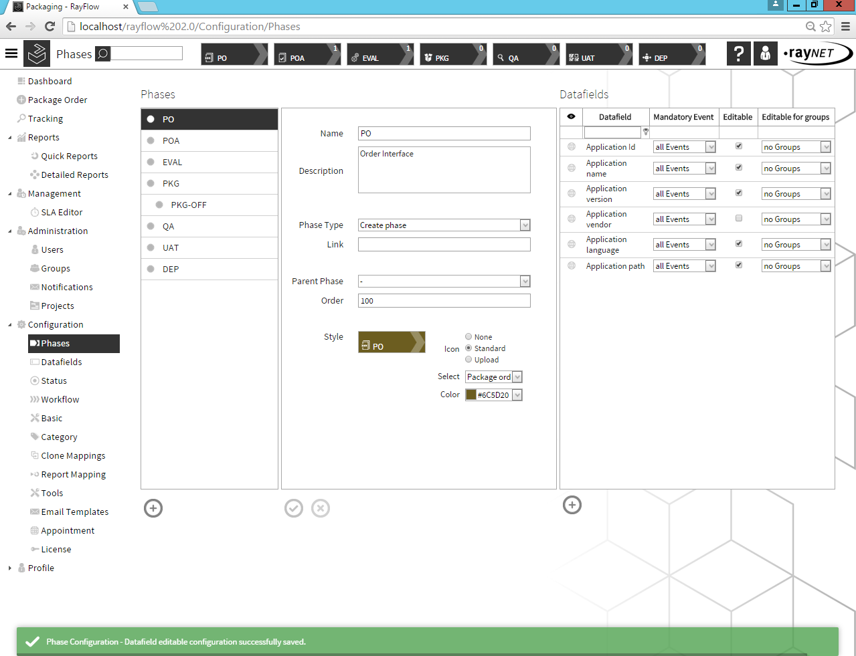

Final state:

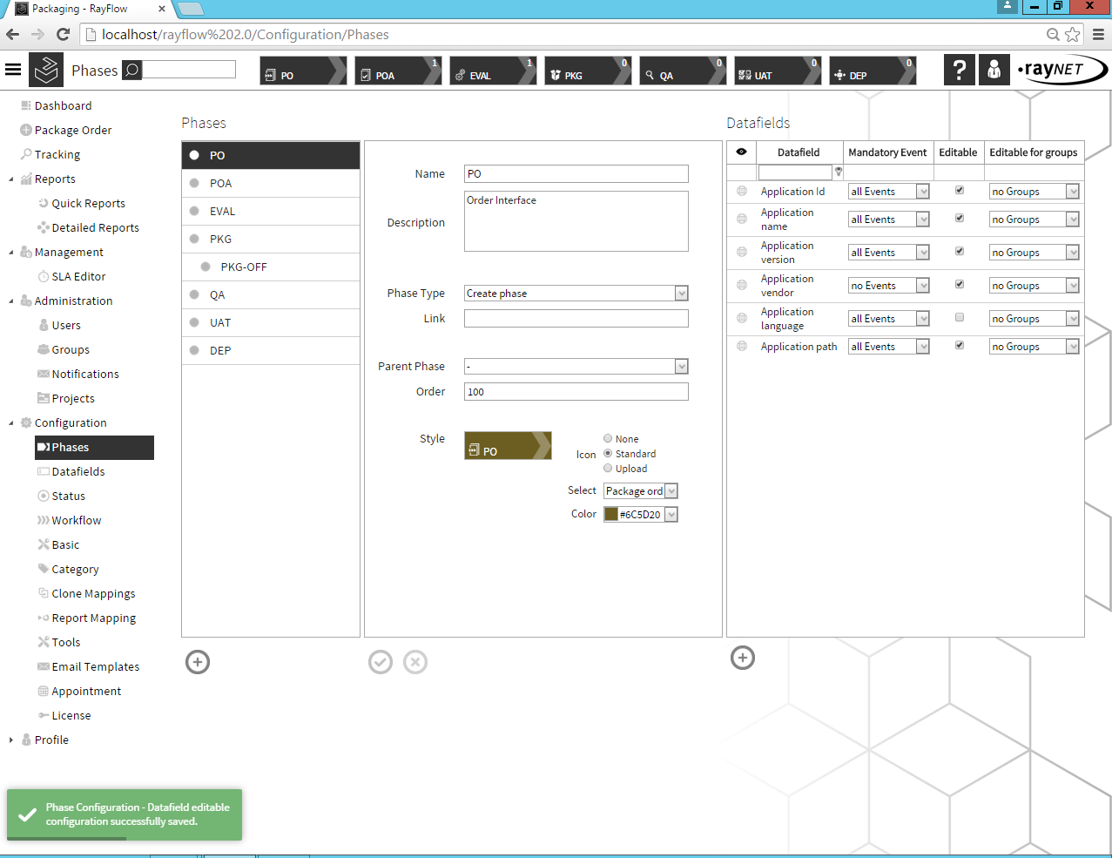

Disclaimer

Toastr is covered under the MIT license - http://www.opensource.org/licenses/mit-license.php

